

**Office Induction Pack**

St Marks Housing Office

14 – 16 Catherine Street

Leicester

LE4 6BA

**St Marks Housing Office**

This document outline’s the responsibilities of **All** Council Employees and will assist in the process of familiarisation and understanding the operation of your designated building.

It is **everyone’s** responsibility to ensure Health and Safety is adhered to and safe working environments are maintained.

2.8 Fire Alarm, Heating & Ventilation Controls

2.7 Cleanliness & Hygiene

2.6 Lockers for Personal Belongings

2.5 First Aid

2.4 Fire Evacuation Procedures

2.3 Door Entry System

2.2 Car Parking

2.9 Reporting Repairs

2.1 Opening Times

**2.0 BUILDING GENERAL**

1.3 Use of Meeting Room and Kitchen

1.2Use of Desk Spaces

1.1Building Access and Egress

**1.0 COVID 19 – OFFICE PROCEDURES**

**Contents**

**1.0 COVID 19 – OFFICE PROCEDURES**

* The measures outlined below have been implemented in accordance with Government’s guidance on managing Covid 19 and are supported by a building specific Covid 19 Risk Assessment and Method Statement approved by the Corporate Health & Safety Team and signed off by the Director of Housing.
* We continue to strongly encourage staff to follow the measures in place to reduce the risk of covid transmission within our buildings.
* Staying healthy

It’s important that we continue with good habits for good health:

* Wash hands frequently
* Stay at home if you're ill
* Keep a distance from others
* Have your vaccinations

1.1Building Access and Egress

* Staff are required to enter and exit the building from the rear of the building, where it is marked ‘Fire Exit’. There is also one other Fire Exit located in the right-hand corner of the main office (if standing in the office facing out). These exits must be used as emergency exits.
* Staff should ensure a good level of personal hygiene and frequently wash hands or use the hand sanitiser provided.

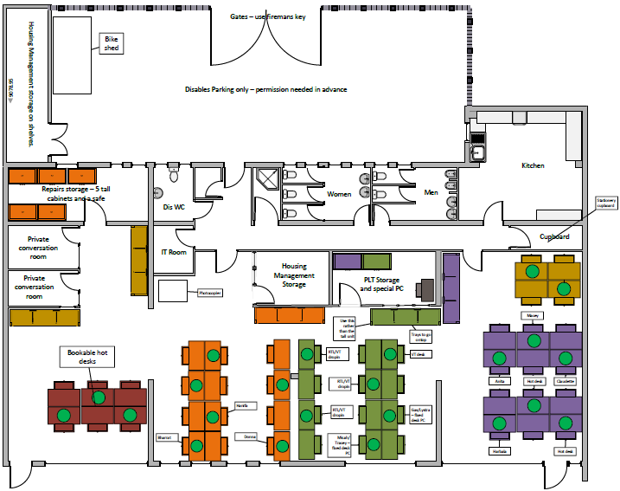

1.2Use of Desk Spaces

* Staff are only to use the desk spaces that have been assigned to their teams and should only sit at a workstation that is marked with a green sticker until further updates are provided by the Building Responsible Officer.
* Staff should not alter or remove the screens separating desk spaces.
* Staff are required to clean their own desks before and after use. Hand sanitisers are situated around the main office area and located on some working desks.
* Staff are required to remove all personal belongings from their desks at the end of every working day.
* Do not store items on window cills.
* Do not affix items to walls.
* Staff should not move or remove any IT Equipment from desks, including leads.

1.3 Use of Meeting Room and Kitchen

* All Staff are required to observe the maximum occupancy levels stated to ensure health and safety is always maintained.
* Staff should take their breaks (food and drinks) at their workstation and can use the communal kitchen.

2.1 Opening Times

**2.0 BUILDING GENERAL**

* Monday to Thursday 8:00am – 16:00pm
* Friday 8:00am – 15:30pm
* Closed Weekends and Bank Holidays

2.2 Car Parking

* There is plenty of on street parking available near the office and all spaces are available on a first come first served basis.

2.3 Door Entry System

* The building is fitted with the corporate access control system called ‘Progeny’. If you have not been issued with a new smart card you arrange this by emailing IDbadge@leicester.gov.uk

2.4 Fire Evacuation Procedures

* All Staff should ensure that they are familiar with the Fire Evacuation Procedure which accompanies this document.
* The Fire Evacuation Procedure outlines the actions to be taken by **All Staff** working within the building in the event of a fire.
* Failure to observe this procedure could put people’s life at risk. Your co-operation will help to ensure everyone’s safety in an emergency.

2.5 First Aid

* The designed First Aid location for the building is the Kitchen area and details of on-site First Aiders can also be found there on the notice board.

2.6 Lockers for Personal Belongings

* Staff have access to secure lockers located with the main office area for the storage of personal items.

N.B.

Leicester City Council does not accept any liability for loss or damage of personal items.

2.7 Cleanliness & Hygiene

* Please respect the welfare facilities within the building.
* **Kitchen**

Please ensure the Kitchen is kept clean and tidy. Everyone who uses this area has a responsibility for its general cleanliness.

* Wash any items you use.
* Take home or dispose of leftover food including any items stored within the fridges.
* Take home or dispose of food or drink containers.
* Wipe up spills and messes from works surfaces or on/inside appliances.
* **Toilets**

Please leave the toilets clean for the next user.

* Flush after use and clean off the seat as necessary.
* Use toilet paper and water conservatively.
* Wash your hands before leaving the room.

2.8 Fire Alarm, Heating & Ventilation Controls

* Please do not tamper with any control systems located within the building. Doing this will have a detrimental impact on the building’s operation.

2.9 Reporting Repairs

* If you need to report a repair, please email [imcsite-admin@leicester.gov.uk](mailto:imcsite-admin@leicester.gov.uk)