

**Office Induction Pack**

New Parks Housing Office

321 Aikman Avenue

Leicester

LE3 9PW

**New Parks Housing Office**

This document outline’s the responsibilities of **All** Council Employees and will assist in the process of familiarisation and understanding the operation of your designated building.

It is **everyone’s** responsibility to ensure Health and Safety is adhered to and safe working environments are maintained.

**Contents**

**1.0 COVID 19 – OFFICE PROCEDURES**

1.1 Building Access and Egress

1.2 Use of Desk Spaces

1.3 Use of Meeting Room and Kitchen

**2.0 BUILDING GENERAL**

2.1 Opening Times

2.2 Car Parking

2.3 Door Entry System

2.4 Fire Evacuation Procedures

2.5 First Aid

2.6 Cleanliness & Hygiene

2.7 Fire Alarm, Heating & Ventilation Controls

2.8 Reporting Repairs

**1.0 COVID 19 – OFFICE PROCEDURES**

* The measures outlined below have been implemented in accordance with Government’s guidance on managing Covid 19 and are supported by a building specific Covid 19 Risk Assessment and Method Statement approved by the Corporate Health & Safety Team and signed off by the Director of Housing.
* We continue to strongly encourage staff to follow the measures in place to reduce the risk of covid transmission within our buildings.
* Staying healthy

It’s important that we continue with good habits for good health:

* Wash hands frequently
* Stay at home if you're ill
* Keep a distance from others
* Have your vaccinations

1.1 Building Access and Egress

* Staff are required to enter and exit the building from the rear of the building, where it is marked ‘Fire Exit’. There is also another Fire Exit door located in the corridor area. These must be used as emergency exits only.
* Staff should ensure a good level of personal hygiene and frequently wash hands or use the hand sanitiser provided.

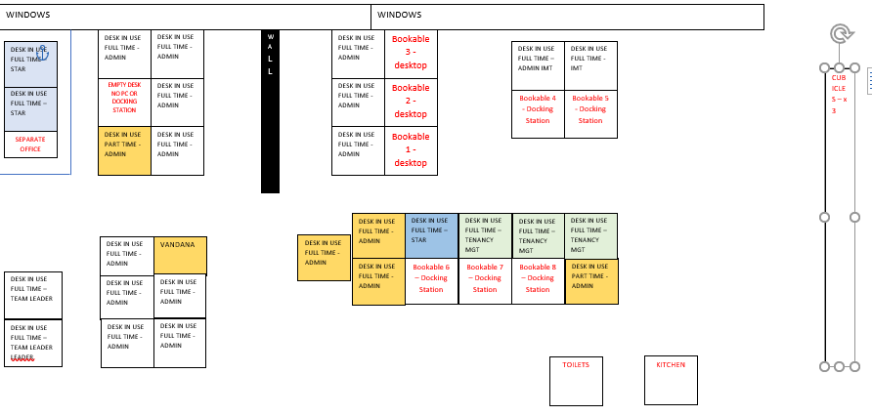

1.2 Use of Desk Spaces

* Staff are only to use the desk spaces that have been assigned to their teams and should only sit at a workstation that is marked with a green sticker until further updates are provided by the Building Responsible Officer.
* Staff should not alter or remove the screens separating desk spaces.
* Staff are required to clean their own desks before and after use. Cleaning caddies are situated around the main office area and include hand sanitiser.
* Staff are required to remove all personal belongings from their desks at the end of every working day.
* Do not store items on window cills.
* Do not affix items to walls.
* Staff should not move or remove any IT Equipment from desks, including leads.

1.3 Use of Meeting Room and Kitchen

* All Staff are required to observe the maximum occupancy levels stated to ensure health and safety is always maintained.
* Staff should take their breaks (food and drinks) at their workstation and can use the communal kitchen.

**2.0 BUILDING GENERAL**

2.1 Opening Times

* Monday to Thursday 8:30am – 17:00pm
* Friday 8:30am – 16:30pm
* Closed Weekends and Bank Holidays

2.2 Car Parking

* There are approx. 9 car park spaces designated at the rear of the building. This consists of 1 disabled space also. All spaces are available on a first come first served basis and there is plenty of on street parking available near the office.

2.3 Door Entry System

* The building is fitted with door entry system which uses a key fob to allow entry to and exit out the building. If you have not been issued with a key fob, then you can arrange this by emailing [landlordservices@leicester.gov.uk](mailto:landlordservices@leicester.gov.uk)

2.4 Fire Evacuation Procedures

* All Staff should ensure that they are familiar with the Fire Evacuation Procedure which accompanies this document.
* The Fire Evacuation Procedure outlines the actions to be taken by **All Staff** working within the building in the event of a fire.
* Failure to observe this procedure could put people’s life at risk. Your co-operation will help to ensure everyone’s safety in an emergency.

2.5 First Aid

* The designed First Aid location for the building is in the main working office (near the signing in book) and other location is in the Kitchen.

2.6 Cleanliness & Hygiene

* Please respect the welfare facilities within the building.
* **Kitchen**

Please ensure the Kitchen is kept clean and tidy. Everyone who uses this area has a responsibility for its general cleanliness.

* Wash any items you use.
* Take home or dispose of leftover food including any items stored within the fridges.
* Take home or dispose of food or drink containers.
* Wipe up spills and messes from works surfaces or on/inside appliances.
* **Toilets**

Please leave the toilets clean for the next user.

* Flush after use and clean off the seat as necessary.
* Use toilet paper and water conservatively.
* Wash your hands before leaving the room.

2.7 Fire Alarm, Heating & Ventilation Controls

* Please do not tamper with any control systems located within the building. Doing this will have a detrimental impact on the building’s operation.

2.8 Reporting Repairs

* If you need to report a repair, please email [landlordservices@leicester.gov.uk](mailto:landlordservices@leicester.gov.uk)