Office Induction Pack
Mowmacre Hill Hub
Jersey Road
Leicester
LE4 2LT

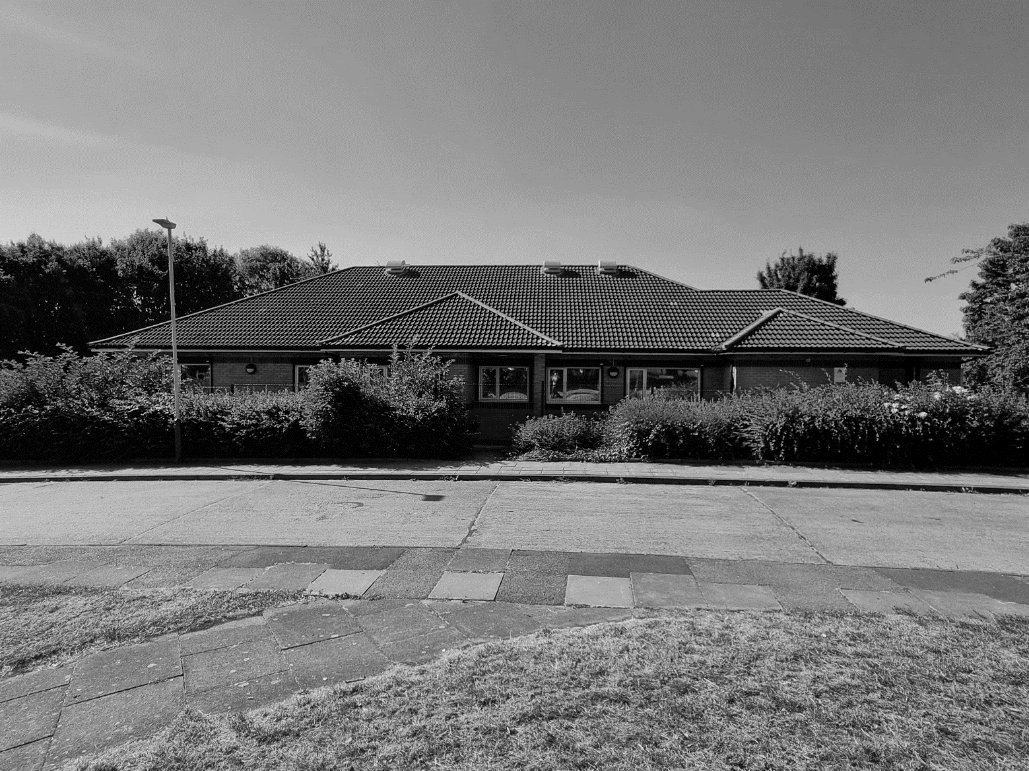

Technical Services - Housing Rev 4.0 01-09-22
Mowmacre Hill Hub

This document outline’s the responsibilities of All Council Employees and will assist in the process of familiarisation and understanding the operation of your designated building.

It is everyone’s responsibility to ensure Health and Safety is adhered to and safe working environments are maintained.

Contents

1.0 Living Safely with Covid 19

2.0 Opening / Closing Times

3.0 Car Parking

4.0 Fire Evacuation Procedure

5.0 First Aid

6.0 Building Access and Egress

7.0 Use of Desk Spaces

8.0 Use of Meeting Rooms 1, 2 & 3

9.0 Lockers For Work & Personal Belongings

10.0 Cleanliness & Hygiene

11.0 Fire Alarm, Heating & Ventilation Controls

12.0 Reporting Repairs

1.0 Living Safely with Covid 19

- As we learn to live safely with coronavirus (COVID-19), there are actions we can all take to help reduce the risk of catching COVID-19 and passing it on to others. These actions will also help to reduce the spread of other respiratory infections, such as flu, which can spread easily and may cause serious illness in some people.

- There are simple things you can do in your daily life that will help reduce the spread of COVID-19 and other respiratory infections and protect those at highest risk. Things you can choose to do are:

- Get Vaccinated.
Vaccines are the best defence we have against COVID-19 and other respiratory infections such as flu. They also reduce the risk of long-term symptoms.

- Practise Good Hygiene
Following these basic rules of good hygiene will help to protect you and others from COVID-19 as well as many other common infections:

- wash your hands
- cover your cover your nose and mouth when you cough and sneeze
- clean your surroundings frequently

- If you have symptoms of a respiratory infection, such as COVID-19, and you have a high temperature or do not feel well enough to go to work or carry out normal activities, you are advised to try to stay at home and avoid contact with other people.

2.0 Opening / Closing Times

- Monday to Thursday 8:00am – 17:00pm
Friday 8:00am – 16:30pm

- Closed Weekends and Bank Holidays

3.0 Car Parking

- There are two carparks located on site.

- Carparks 1 & 2
For staff use on a ‘First Come First Serve’ basis except for the marked disabled parking spaces. Once these carparks are fully occupied street parking is available within the immediate area.

- Disabled Parking Bays
Will be allocated to Blue Badge Holders only. Do not park in a Disabled Parking Bay unless you have been authorised to do so.

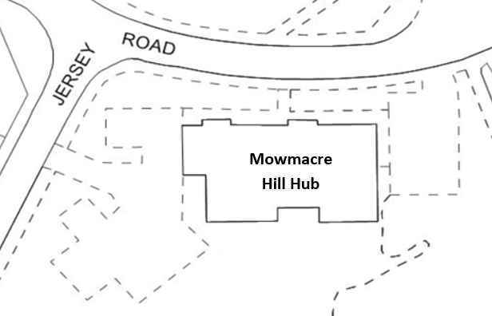
Car Park 1
Car Park 2

4.0 Fire Evacuation Procedure

- All Staff should ensure that they are familiar with the Fire Evacuation Procedure. See supporting guide for details.

- The Fire Evacuation Procedure outlines the actions to be taken by All Staff working within the building in the event of a fire.

- Failure to observe this procedure could put people’s lives at risk. Your co-operation will help to ensure everyone’s safety in an emergency.

5.0 First Aid

- The designed First Aid location for the building is the Kitchen. Details of on-site First Aiders can be found on the First Aid Notice/s.

6.0 Building Access and Egress

- Staff are required to Enter and Exit the building via the main entrance located at the rear of the building.

- Access to the building is controlled by a door entry system which operates via a corporate ID badge. If you do not have one of these ID badges please speak to you line manager.

- The main door and inner lobby doors both operate automatically. Forcing these open or closed will damage the mechanism. Once inside the building these door can be opened by pressing the button shown below which are located adjacent to each set of doors.

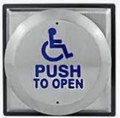

- Doors marked Fire Exits located adjacent to the kitchen and at the rear of the main office are only to be used in the event of an Emergency.

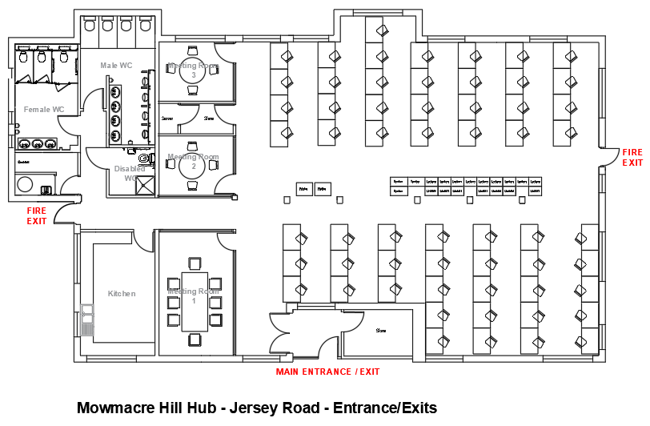

- Use of Desk Spaces

- Staff should only use the desk spaces that have been assigned for their own teams use or a desk that they have booked in advance via the Touchdown Desk Space Booking System.

- Staff are required to clean their own desks before and after use. Cleaning caddies are situated within the main office area and include hand sanitiser, gloves, cloths, and spray. Keeping workplaces clean reduces the risk of infection and can reduce sickness in a workforce.

- Staff are required to remove all work-related items and personal belongings from their desks at the end of every working day. Lockers are available for use to store these items (See ?? below)

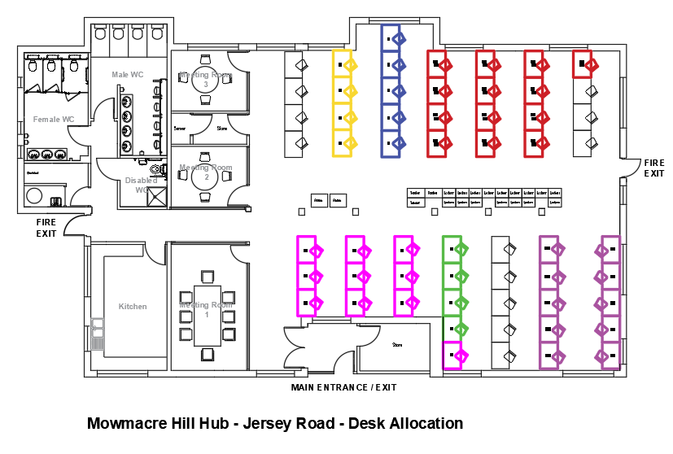

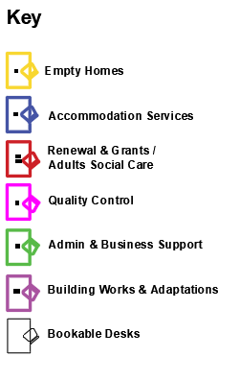
- Use of Meeting Rooms 1, 2 & 3

- All three Meeting Rooms should be booked in advance via The Meeting Room Booking System. See supporting guide for details.

Room Finder Reference

- JerseyRdMeetingRm1 (Maximum Capacity 8)
- JerseyRdMeetingRm2 (Maximum Capacity 4)
- JerseyRdMeetingRm3 (Maximum Capacity 4)

- Meeting Room capacity is dictated by the total number of chairs in each room. Do not remove chairs or bring extra chairs into any of these locations

- Please do out stick paper signs on to the doors. Only bookings via the system will be recognised.

9.0 Lockers For Work & Personal Belongings

- All Staff have access to secure lockers located with the main office area for the storage of personal items.

N.B.
Leicester City Council does not accept any liability for loss or damage of personal items.

- Instructions on setting and changing the code can be found at the following links:

Setting The Use Code
https://www.lehmann-locks.com/files/videos/Utilitys/dl59_code-einstellen_eng_web.mp4

Changing The User Code
https://www.lehmann-locks.com/files/videos/Utilitys/dl59_code-aendern_eng_web.mp4

Note
(Please use the end of a pen as a substitute for the tool shown in the videos)

10.0 Cleanliness & Hygiene

- Please respect the welfare facilities within the building.

- Kitchen
Please ensure the Kitchen is kept clean and tidy. Everyone who uses this area has a responsibility for its general cleanliness.

- Wash any items you use.
- Take home or dispose of leftover food including any items stored within the fridges.
- Take home or dispose of food or drink containers.
- Wipe up spills and messes from works surfaces or on/inside appliances.

- Toilets
Please leave the toilets clean for the next user.

- Flush after use and clean off the seat as necessary.
- Use toilet paper and water conservatively.
- Wash your hands before leaving the room.

11.0 Fire Alarm, Heating & Ventilation Controls

- Please do not tamper with any control systems located within the building. Doing this will have a detrimental impact on the building’s operation.

12.0 Reporting Repairs

- If you need to report a repair please email Mowmacre-Hill-Hub@leicester.gov.uk

