

**Fire Evacuation Procedure**

**Mowmacre Hill Hub**

Jersey Road

Leicester

**LE4 2LT**

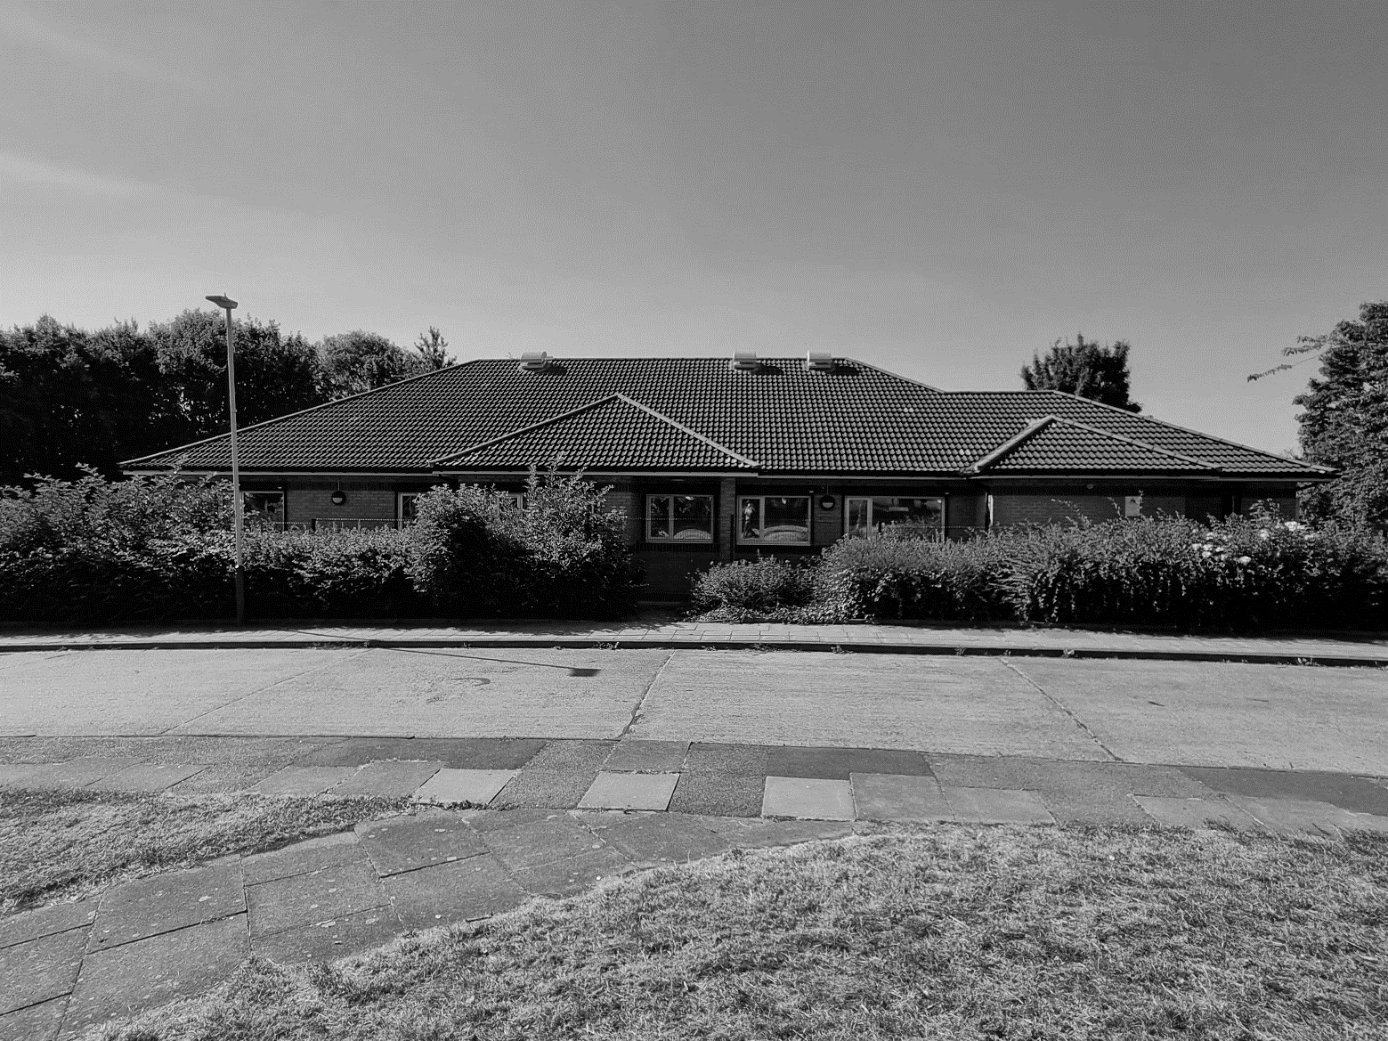

**Technical Services - Housing Rev 6.0 26-02-25**

|  |
| --- |
| **Fire Evacuation Procedure** |

This document outlines the actions to be taken by **ALL** staff working within the building in the event of a fire.

Failure to observe this procedure could put people’s lives at risk. Your co-operation will help to ensure everyone’s safety in an emergency.

The building has been designed to prevent the spread of fire and smoke, allowing staff time to evacuate to a place of safety should the need arise.

The building is fitted with automatic smoke/heat detection sensors and alarm sounders in all areas. Manually operated fire alarm call points are located at all exits and firefighting appliances have been provided for use in an emergency.

Evacuation routes are clearly marked and protected by fire doors fitted with self-closing devices.

**ALL** staff have a duty to ensure that:

* They are familiar with the evacuation procedure.
* Evacuation routes are free from obstructions and combustible materials.
* Fire doors are not wedged open.
* Firefighting appliances are not interfered with.

|  |
| --- |
| **Contents** |

|  |
| --- |
| **1.0 KEY ROLES & RESPONSIBILITIES** |

|  |
| --- |
| **1.1 Building Control Officer (BCO)** |

|  |
| --- |
| **1.2 Fire Marshall (FM)** |

|  |
| --- |
| **1.3 First Aiders (FA)** |

|  |
| --- |
| **1.4 Managers - Senior Technicians - Team Leaders** |

|  |
| --- |
| **2.0 BUILDING LAYOUT PLANS** |

|  |
| --- |
| **2.1 Fire Exits / Fire Alarm Control Panel / Fire Alarm Call Points / Fire Fighting Equipment** |

|  |
| --- |
| **2.2 BCO Control Point & FM Point** |

|  |
| --- |
| **2.3 Emergency Assembly Point** |

|  |
| --- |
| **2.0 ALL STAFF** |

|  |
| --- |
| **2.1 On Discovering A Fire** |

|  |
| --- |
| **2.2 On Hearing The Fire Alarm** |

|  |
| --- |
| **3.0 BUILDING CONTROL OFFICER (BCO)** |

|  |
| --- |
| **3.1 On Hearing the Alarm** |

|  |
| --- |
| **3.2 On Confirmation of a Fire** |

|  |
| --- |
| **3.3 When The Fire Service Arrive** |

|  |
| --- |
| **3.3 Post Incident** |

|  |
| --- |
| **3.3 False Alarms** |

|  |
| --- |
| **4.0 FIRE MARSHAL (FM)** |

|  |
| --- |
| **4.1 On Hearing the Alarm** |

|  |
| --- |
| **5.0 FIRST AIDERS (FA)** |

|  |
| --- |
| **5.1 On Hearing the Alarm** |

|  |
| --- |
| **6.0 OUT OF HOURS ACTIVATIONS** |
| **1.0 KEY ROLES & RESPONSIBILITIES** |

|  |
| --- |
| **1.1 Building Control Officer (BCO)** |

* The Building Control Officer (BCO) will be any Technical Manager, Senior Technician or Team Leader who is working at the building during the time of the emergency.

|  |
| --- |
| **1.2 Fire Marshall (FM)** |

* The Fire Marshal will be any responsible person working in the office at the time of the emergency who takes responsibility for the clearance of the area in which they are working. Normally this will be the first person to reach the designated (FM) Point within the main office and put on the Hi-Viz vest.

|  |
| --- |
| **1.3 First Aiders (FA)** |

* Are those staff who have received the required training and are aware of their duties in the event of an incident.

|  |
| --- |
| **1.4 Managers - Senior Technicians - Team Leaders** |

* Should ensure that all new, existing, and temporary staff are given on-site training and issued with a full copy of the fire evacuation procedures.
* Should ensure that a Personal Emergency Evacuation Plan (PEEP) is completed for each person in the team with a disability (to include short and long term temporary staff) and provide a copy to the Building Responsibly Officer so that evacuation plans can be put in place.
* Where delegated by the Building Responsible Officer will:
* Carryout daily checks of the fire panel to ensure normal operation of the system and take the necessary actions to address faults.
* Carryout monthly testing of the fire alarm system and check that the connection to the monitoring centre is functioning correctly.
* Records all checks with the Fire Safety Logbook.

|  |
| --- |
| **2.0 BUILDING LAYOUT PLANS** |

|  |
| --- |
| **2.1 Fire Exits / Fire Alarm Control Panel / Fire Alarm Call Points / Fire Fighting Equipment** |

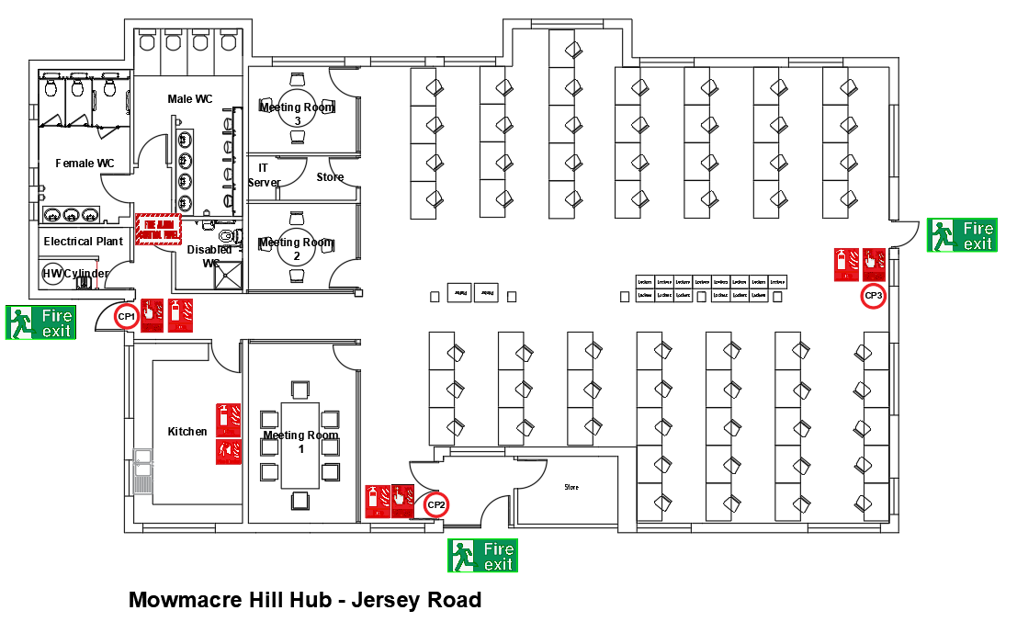

|  |
| --- |
| * 1. **BCO Control Point & FM Point** |

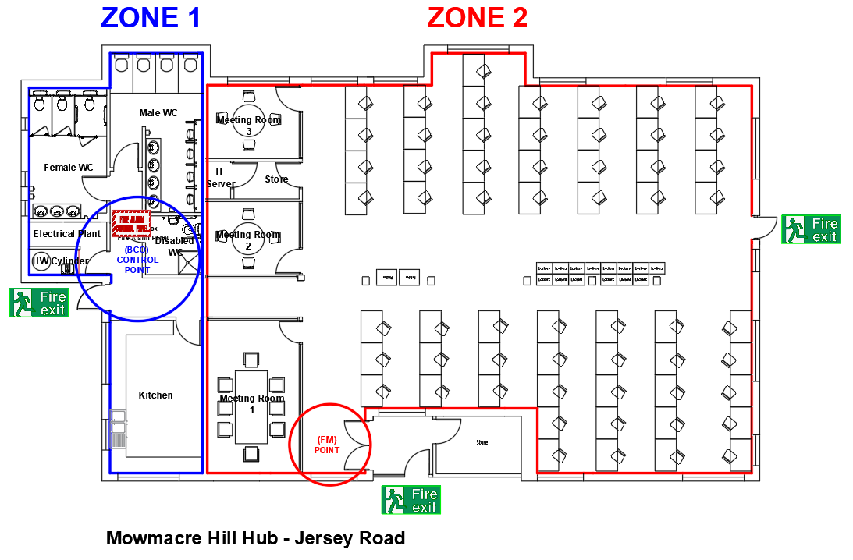

|  |
| --- |
| **2.3 Emergency Assembly Point** |

* The designated **Emergency Assembly Point** is the Main Car Park identifiable by the sign fitted to the fence in this location.

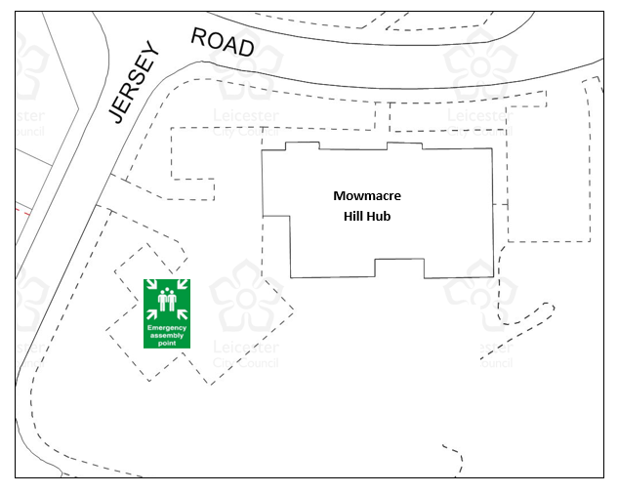

**Mowmacre Hill Hub**

|  |
| --- |
| **3.0 ALL STAFF** |

|  |
| --- |
| **3.1 All Staff - On Discovering A Fire** |

* Sound the Fire Alarm by breaking the glass in the nearest Fire Alarm call point before exiting the building.
* Do not attempt to tackle the fire unless you have been trained to do so.
* Report immediately to the BCO CONTROL POINT (Side Door of Main Carpark) as detailed on the attached layout plan and inform the BCO of the location of the fire. (This person will be identifiable by wearing a Hi-Viz vest)

|  |
| --- |
| **3.2 All Staff - On Hearing The Fire Alarm** |

* **LEAVE THE BUILDING BY THE NEAREST FIRE EXIT.**
* Do not return to your own workstation to collect personal belongings.
* If you have a visitor on site please ensure they are accounted for when leaving the building.
* Report to the **Emergency Assembly Point** within the main carpark and await further instructions.
* Do not attempt to return to the building until you are told it is safe to do so.
* ***N.B.***

If you know that you have caused a ‘False Alarm’ report this immediately to the BCO at the BCO CONTROL POINT (Side Door of Main Carpark) as detailed on the attached layout plan.

|  |
| --- |
| **4.0 BUILDING CONTROL OFFICER (BCO)** |

|  |
| --- |
| **4.1 Building Control Officer (BCO) - On Hearing the Fire Alarm** |

* Proceed at once to the BCO CONTROL POINT (Side Door of Main Carpark) as detailed on the attached layout plan.
* From within the Red Fire Documents Box (Located within the BCO CONTROL POINT) collect:
* The High Viz Vest
* The Site Drawings
* If safe to do so carry out a search of the **ZONE 1** as detailed on the attached layout plan comprising Toilets and Kitchen area.

* Wait for the (FM) to arrive at the BCO CONTROL POINT and confirm:
* That they have evacuated **ZONE 2** (Main Office and all Meetings Rooms)?
* If the Fire is located within any of the areas evacuated. If so where?
* They have collected the visitors’ book.
* If the alarm has been activated by an individual, they will report to the BCO CONTROL POINT and provide details of the incident.
* If no one immediately reports to the BCO CONTROL POINT:

* From the Fire Alarm panel ascertain the location of the alarm activation and if safe to do so request the (FM) to check the area and report back accordingly.

|  |
| --- |
| **4.2 Building Control Officer (BCO) - On Confirmation of a Fire** |

* Call **999** quoting location:Mowmacre Hill Hub, Jersey Road, Leicester, LE4 2LT
* Notify the Building Responsible Officer/s if not already on site:
* James Rhodes Tel: 07961 748400
* Jenni Venables Tel: 07710 148692

|  |
| --- |
| **4.3 Building Control Officer (BCO) - When The Fire Service Arrive** |

* Inform the Fire Service of the position and extent of the fire. The location should be identified on the site drawing and handed to the Fire Service.
* Report progress of the evacuation and the position of any person requiring rescue.
* Ensure full liaison with the (FM) and/or the Staff member who reported the fire.
* Place yourself at the disposal of the Fire Service who will take complete control of the incident until the emergency is over.
* Direct the (FM) to go to the **Emergency Assembly Point** with the visitors’ book to ensure all staff, visitors/contractors are accounted for.

|  |
| --- |
| **4.4 Building Control Officer (BCO) - Post Incident** |

* Arrange a debriefing meeting with the Building Responsibly Officer, Fire Marshall, and Corporate Health & Safety Advisor to review the evacuation and draw up an action plan as necessary.
* Update the Fire Safety Logbook.

|  |
| --- |
| **4.5 Building Control Officer (BCO) - False Alarms** |

* If there is no evidence of a Fire and no reports of a Fire from Staff or the (FM) then the building should be checked jointly by the (BCO) and the (FM) to ensure it is safe before allowing staff to return.
* When you are sure that there is no Fire, the alarm can be silenced and Reset*, and you can give the instruction for staff to return to the building.

*Reset Note.

For a Break Glass activation, the devise will need to reset using the white plastic key contained on the same keychain for opening the fire document box.

For a smoke/heat detector activation, the affected zone will need to be ventilated before attempting to reset the panel. (Window keys are located in the key box within the electrical plant room (Tag Ref 19)

* Ensure all documentation and Hi-Viz vests are returned to their locations.
* Report any faults with the fire alarm.
* Arrange a debriefing meeting with the Building Responsibly Officer and Fire Marshall to review the evacuation and draw up an action plan as necessary.
* Update the Fire Safety Logbook.

|  |
| --- |
| **5.0 FIRE MARSHAL (FM)** |

|  |
| --- |
| **5.1 Fire Marshal (FM) - On Hearing the Alarm** |

* If you are the first (or only) person to reach the designated (FM) Point (Adjacent to Main Entrance Inner Doors) as shown on attached layout plan collect the High-Viz vest and Visitors Book.
* If safe to do so carry out a search of the **ZONE 2** as detailed on the attached layout plan comprising Main Office and all Meetings Rooms.
* Ensure all persons leave the area in an orderly fashion by the nearest designated fire exit as detailed on the attached layout plan. If a route becomes blocked re-direct to the nearest alternative exit.
* Do not enter rooms or open doors where you suspect there is a fire. Take note of the location and report this to the BCO.
* Once all locations are confirmed clear report to the BCO CONTROL POINT and liaise with the (BCO) for further instructions.

|  |
| --- |
| **6.0 FIRST AIDERS (FA)** |

|  |
| --- |
| **6.1 First Aiders (FA) - On Hearing the Alarm** |

* First Aiders should on hearing the Fire Alarm proceed to the **Emergency Assembly Point** (within the main carpark) with their first aid kits and wearing their Green Hi-Viz vests.

|  |
| --- |
| **7.0 OUT OF HOURS ACTIVATIONS** |

* A designated keyholder will be contacted and attend the site.

This means outside of the hours 08:00am to 17.00pm Mondays to Thursdays and 08:00am to 16:30pm Fridays. (This includes Saturday/Sunday and Bank Holidays)